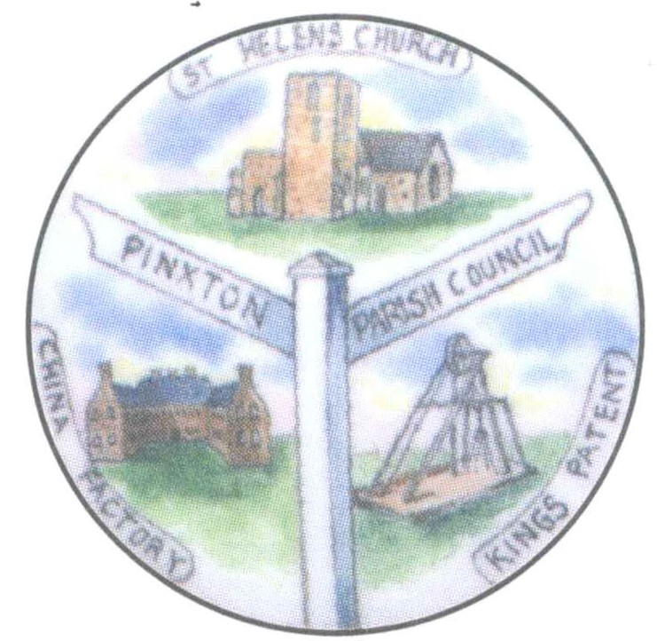

Notice is hereby given that the Annual Meeting of the Parish of Pinxton will be held in the Village Hall, Pinxton on Wednesday 18th May 2022 at 6.30p.m.
under the Chairmanship of Councillor M Hinman.
All Electors of the Parish are entitled to attend.

The business to be transacted at the meeting will be as follows:-

AGENDA

1. To receive apologies for absence.

2. To appoint Clerk for the taking of Minutes for the meeting.

3. To be advised of the Parish Council’s Precept for 2022/2023.

4. To receive the Annual report from the Chair of the Council.

5. To receive questions/comments on Parish Affairs

6. To receive reports from any community groups wishing to report.

Signed ……………………………
Chair of the Parish Council

11th May 2021

