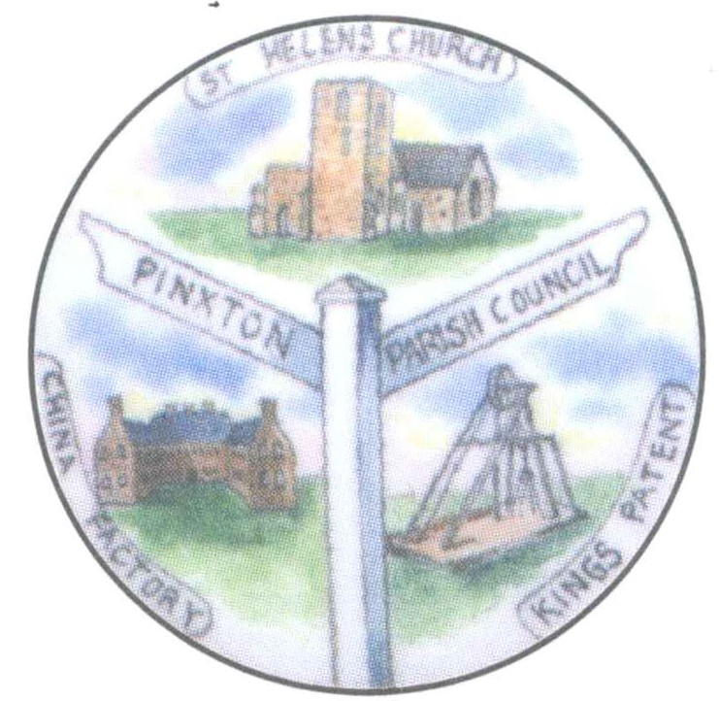Pinxton Village Hall

Pinxton Parish Council

Pinxton Parish Council

3 Kirkstead Road

Pinxton

Derbyshire

NG16 6NA

01773 580046

10th May 2023

**The Annual meeting of Pinxton Parish Council will take place on Wednesday 17th May 2023, the meeting will commence at approximately 7.00pm straight after the Annual Parish meeting which commences at 6.30pm.**

**This meeting will be held in the Village Hall, 3 Kirkstead Road, Pinxton, NG16 6NA.**

**Yours sincerely**



**Lisa J Powell (Ms)**

**Clerk & RFO**

This council supports the rights of anyone to record this meeting but advises that anyone so recording cannot disrupt the meeting, by means of the recording, and expresses the hope that the person (or persons) carrying out the recording have obtained the necessary legal advice, for themselves, to ensure they understand the rights of any members of the public who may be present who do not wish to be filmed or recorded

**AGENDA**

**23/****001 Election of Chairman of the Council and Acceptance of Office**

**To elect a Chairman for the ensuing year.**

**23/002 Election of Vice Chairman of the Council and Acceptance of Office**

**To elect a Vice Chairman for the ensuing year.**

**23/003 To receive apologies for absence – When giving apologies please ensure reasons for non attendance are given and apologies are with the Clerk by 4pm on the day of the meeting.**

**23/004 To receive Declaration of Members Interest/Update of Register – if you require**

**guidance from the Parish Clerk this must be sought well in advance of the meeting and, in any event, by no later than 5pm two working days before the day of the meeting**

**Please note: Members must ensure that they complete the Declaration of Interest sheet prior to the start of the meeting. Column 5 of the Declaration of Interest sheet must be completed in all cases to indciate the action to be taken.**

**23/005 To receive and approve requests for dispensations from members on matters in which they have a Disclosable Pecuniary Interest.**

**23/006 To determine which items, if any, should be taken with the public excluded. If the Council decides to exclude the public it will be necessary to pass a resolution in the following terms: “In view of the confidential nature of some items, it may be necessary to discuss these items with the Public and Press excluded in accordance with the Public Bodies (Admission to Meetings) Act 1960, S1.**

**23/007 Minutes**

**To confirm or amend, as appropriate, minutes of the Full Parish Council meeting held Wednesday 19th April 2023 – Appendix 1**

**23/008 To note updates on matters arising from the minutes (for information only)**

**23/009 Public Speaking**

**009.1 Parishioner Matters**

**009.2 Police Matters**

**009.3 Reports from Council Representatives on Outside Bodies**

**009.4 Reports from District and County Councillor Representatives on matters of direct relevance to Pinxton Parishioners**

**23/010 Planning Applications**

**To receive, and where appropriate comment on recent planning applications and decisions – Appendix 2**

**23/011 Parish Council – Items for Decision/Action**

**011.01 Outside Bodies**

**To elect representatives to sit on outside bodies.**

**011.02 HR Committee**

**To elect representetives to sit on the HR Committee (5 in total including the Chair).**

**011.03 Christmas Lights Working Group**

**To consider setting up a Christmas Lights Working Group as the contract with Festive Lighting has ended.**

**011.04 Freeman of Pinxton**

**To consider awarding David Sawyer the Freedom of Pinxton Award for his contribution in the sport of weightlifting (nominated by Cllr Street) – Appendix 3**

**011.05 Cemetery Bench**

**To consider the request from Lorraine Ball to have a bench in the cemetery in rememberance of her late Father – Appendix 4.**

**011.06 Active Communities Programme**

**To receive the letter from Wayne Hatton (BDC) regarding the end of the Active Communities Programme grant - Appendix 5**

**011.07 General Power of Competance**

To resolve from 17th May 2023, until the next relevant Annual Meeting of the Council in May 2023, that the Council is eligible to use and adopt the General Power of Competence (Localism Act 2011 sections 1-8) as the number of members elected at the 2019 ordinary elections is equal to or greater than two thirds of the total number of seats on the Council and that the Council has a qualified Clerk, as defined in section 2 of The Parish Councils (General Power of Competence) (Prescribed Conditions) Order 2012 (Statutory Instrument 2012 No. 965) – **Appendix 6**

**011.08 Footpaths**

**To receive an update on footpaths in the area.**

**011.09 Councillor Co-option**

**To co-opt a parish councillor for the Broadmeadows ward (only two candidates stood at the election for the three seats).**

**23/012 To receive – Clerks Report**

* **The Multi-purpose is proving a big hit and has become a show piece for other councils to view**
* **The hanging baskets will be put up soon.**
* **We are having problems with the van again.**
* **The Coronation benches will be put in place soon.**
* **The electrical testing has been carried out at all sites.**
* **The new windows for the village hall are on order**

**23/013 To note – Correspondence received (Copies available from Clerk upon request)**

* **NALC Chief Executives April 2022**
* **Clerks & Councils Direct Magazine May 2022**
* **DALC Newsletter May 2023**
* **Friends of Cromford Canal Erewash Rally**
* **SNAP Team Newsletter May**
* **Letter to resident re: defamation of councillor’s characters**

**23/014 Date of the next Parish Council meeting – 21st June 2023 7pm in the Village Hall,**

**3 Kirkstead Road, Pinxton, NG16 6NA**

**………………………………………..………………..**